BANK ACCOUNTS MANAGEMENT
SYSTEM

Șutea Adrian

Group 30425

Table of contents

1. Objective

1.1 Description . . . . . . . . . . . . . . . . . . . . . . . . . . . . . . . . . . . . . . . . . . . . . . . . . . . . . . page 3

2. Problem analysis . . . . . . . . . . . . . . . . . . . . . . . . . . . . . . . . . . . . . . . . . . . . . . . . . page 4

3. Diagrams

3.1 UML Class diagram . . . . . . . . . . . . . . . . . . . . . . . . . . . . . . . . . . . . . . . . . . . . . . . page 5

3.2 UML Use-case diagram . . . . . . . . . . . . . . . . . . . . . . . . . . . . . . . . . . . . . . . . . . . . page 6

3.3 UML Sequence diagram. . . . . . . . . . . . . . . . . . . . . . . . . . . . . . . . . . . . . . . . . . . . page 7

3.4 UML Activity diagram . . . . . . . . . . . . . . . . . . . . . . . . . . . . . . . . . . . . . . . . . . . . . . page 7

3.5 UML Package diagram . . . . . . . . . . . . . . . . . . . . . . . . . . . . . . . . . . . . . . . . . . . . . page 8

4. Implementation

4.1 Implementation and testing . . . . . . . . . . . . . . . . . . . . . . . . . . . . . . . . . . . . . . . . . .page 8

4.2 Implementation details . . . . . . . . . . . . . . . . . . . . . . . . . . . . . . . . . . . . . . . . . . . . . page 8

5. Conclusions . . . . . . . . . . . . . . . . . . . . . . . . . . . . . . . . . . . . . . . . . . . . . . . . . . . . page 10

6. Bibliography . . . . . . . . . . . . . . . . . . . . . . . . . . . . . . . . . . . . . . . . . . . . . . . . . . . . page 10

1. Objective
Consider the system of classes in the class diagram below.
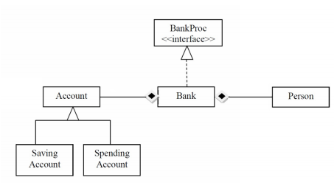
1. Define the interface BankProc (add/remove persons, add/remove holder associated accounts, read/write accounts data, report generators, etc). Specify the pre and post conditions for the interface methods.
2. Define and implement the classes Person, Account, SavingAccount and SpendingAccount. Other classes may be added as needed (give reasons for the new added classes).
3. An Observer DP will be defined and implemented. It will notify the account main holder about any account related operation.
4. Implement the class Bank using a predefined collection which uses a hashtable. The hashtable key will be generated based on the account main holder (ro. titularul contului). A person may act as main holder for many accounts. Use JTable to display Bank related information.
4.1 Define a method of type “well formed” for the class Bank.
4.2 Implement the class using Design by Contract method (involving pre, post conditions, invariants, and assertions).
5. Implement a test driver for the system.
6. The account data for populating the Bank object will be loaded/saved from/to a file.

1.1. Description
The goal of this project is to realize and implement an application that simulates a bank management system. The main objective is to analyze the input data and to create structures for stocking them. From the requirements of the project we can deduce some general aspects: the software should use as input data, the account details, the client’s details and the sum to be added or withdrawn.
The application first generates a log in screen, from which it can see if the user is an administrator or a regular user (a client). The administrator is able to add and remove accounts, add and remove persons, see the details of all the accounts and serialize the class bank. The client can add funds to his accounts, withdraw funds from his accounts, see the details of all it’s accounts and serialize the class bank.
For interactioning with the user, the application has an graphic user interface based on the Java Swing.

2. Problem analysis
For modelling the application we must determine the entities and the way of implementation. I have identified the next entities that must be implemented in this kind of application:
BankProc interface – this interface declares the method names for the bank class.

Person Class – this class retains information about a specific person. The main attributes of a product are: name and SSN. The class body also contains getters and setters for accessing each one of the product’s attributes and a update method used to show a message when the class is notified via the Observer.

Account Class – this is an abstract class. It’s constructor gets as parameters an id, a person and a sum and sets them for a new account. The main attributes of an account are an id, a person, a sum and a type. The class body contains getters and setters for all the class’s attributes and two abstract methods for adding and withdrawing money from the account.

SpendingAccount Class – this class’s constructor gets as parameters an id, a person and a sum and sets them for a new spending account. It also extends the account class, so it implements the methods for adding and withdrawing money from the spending account.

SavingAccount Class – this class’s constructor gets as parameters an id, a person and a sum and sets them for a new spending account. It also extends the account class, so it implements the methods for adding and withdrawing money from the spending account.

Gui Class – it creates the initial log in screen from which the type of user is determined. After the user is determined, this class creates different graphical user interfaces depending on whether the user is an administrator or a regular user.

AdminGui Class – this class is created by the Gui class if the user is an administrator. It contains: buttons for each operation that can be done by the administrator, text fields for the person name, perosn SSN, account ID and account type, and a table where the account details are shown for each person. The table needs to be refreshed after each operation in order for the modifications to be seen on it.

UserGui Class – this class is created by the Gui class if the user is a regular one (a client). It contains: buttons for each operation that can be done by a regular user, text fields for the account id and the sum to be withdrawn, and a table where the account details of the user are shown. The table needs to be refreshed after each operation in order for the modifications to be seen on it.

Bank Class – this is the biggest class of the project. It has as attributes an HashMap of accounts and an ArrayList of clients. The class body contains methods for adding and removing accounts, adding and removing persons, search a person and a few other methods. All the methods of this class have pre and post conditions written with assert.

BankTest Class – this class is a test class that has as parameter a instance of the bank class. It tests some of the methods of the bank class. It is implemented using JUnit.

Main Class – this class creates an instance of the Gui class in order for the whole program to be able to run.

More information about the functionality of these classes will be presented in the „implementations details” section of this document.

3. Diagrams

3.1. UML Class Diagram
The class diagram with the relationships between classes is shown below .
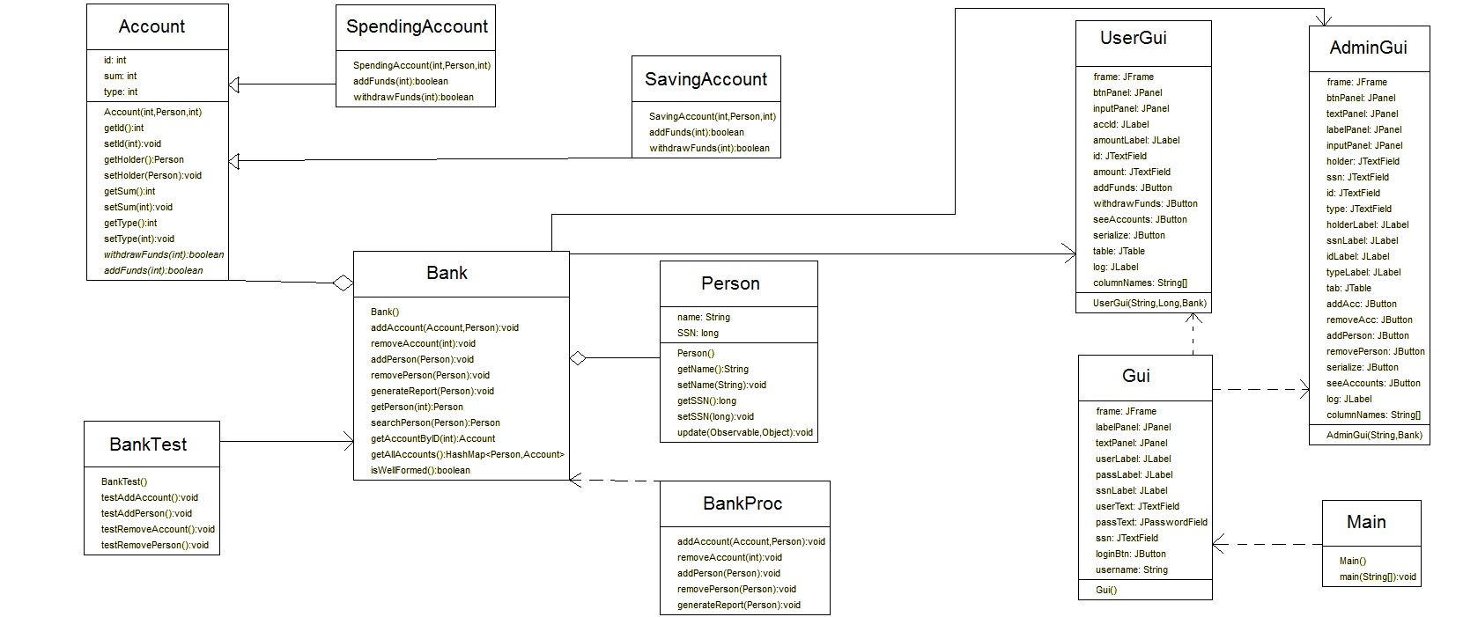

Relationships between classes

The Main class is responsible for creating the Gui class (graphic user interface) and it has a dependency relationship with it. The AdminGui and UserGui classes have a dependency relationship with the Gui class. The Account class has a inheritance relationship with the SavingAccount and SpendingAccount and an aggregation realtionship with the Bank class. The Person class also has a aggregation realtionship with the Bank. The BankTest, UserGui and AdminGui classes have a direct association relationship with the Bank class.

3.2. UML Use-case diagram
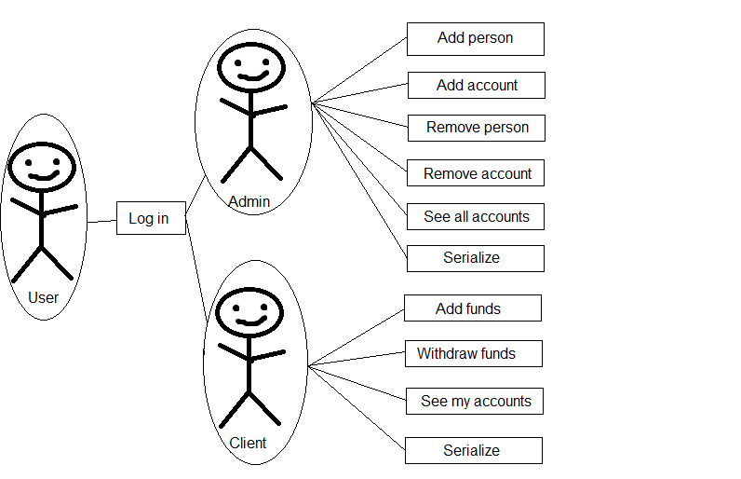

3.3. UML Sequence diagram
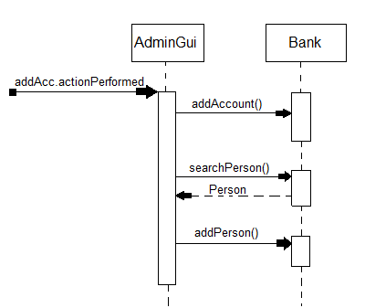

3.4. UML Activity diagram
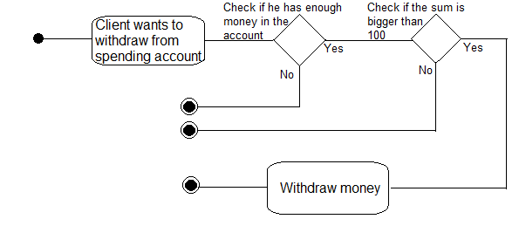

3.5. UML Package diagram
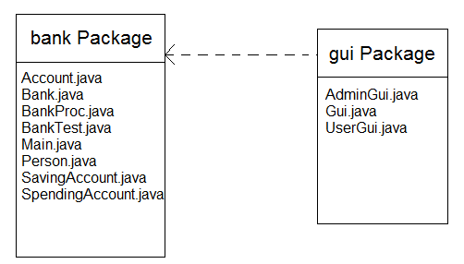

4. Implementation

4. 1. Implementation and testing
In what the implementation is concerned this project was developed in Eclipse and it was only tested in this environment. However the program should maintain its portability. Concerning the code implementation I did not make use of laborious algorithms, but I have rather stayed faithful to the classical algorithms of computing polynomials learned in high school. However I have tried to implement my problem in a way that appears to me as being the most efficient one, that is why I have changed my model at first.
Testing implies checking for any errors in the program or limitations of this program. Due to the fact that the program is rather simplistic, they are few errors that might generate this program to work wrong or to stop. This errors are mostly related to the interface. I have assumed that the user reads the instructions from the interface and respects them, otherwise if he enters data with invalid format the program will probably generate some bugs and will stop. Hence this part with checking all the possible scenarios will be seen as future development.

4. 2. Implementation details

BankProc interface – this interface declares the method names for the bank class. The methods declared are for adding an account, removing an account, adding a person, removing a person and a method for generating a report. The interface pre and post conditions for all the methods it declares.

Person Class – this class retains information about a specific person. The main attributes of a product are: name and SSN. The class body also contains getters and setters for accessing each one of the product’s attributes and a update method used to show a message when the class is notified via the Observer. The class also implements the Observer and the Serializable interfaces.

Account Class – this is an abstract class. It’s constructor gets as parameters an id, a person and a sum and sets them for a new account. The main attributes of an account are an id, a person, a sum and a type. The class body contains getters and setters for all the class’s attributes and two abstract methods for adding and withdrawing money from the account. This class also implements the Serializable interface and extends the Observable class.

SpendingAccount Class – this class’s constructor gets as parameters an id, a person and a sum and sets them for a new spending account. It also extends the account class, so it implements the methods for adding and withdrawing money from the spending account. The addFunds method checks if the amount to be added is bigger than 10, and if it is then it adds the amount to the existing sum in the account. The withdrawFunds method checks if the amount to be withdrawn is bigger than 100, and if it is the amount is withdrawn from the account sum.

SavingAccount Class – this class’s constructor gets as parameters an id, a person and a sum and sets them for a new spending account. It also extends the account class, so it implements the methods for adding and withdrawing money from the spending account. The addFunds method checks if the amount to be added is bigger than 10, and if it is then it adds the amount to the existing sum in the account. The withdrawFunds method checks if the amount to be withdrawn is equal to the total sum existent in the account, and if it is the amount is withdrawn from the account sum.

Gui Class – the first thing the constructor of this class does is to deserialize the objects from the BankFile.ser file. Then it creates the initial log in screen from which the type of user is determined. After the user is determined, this class creates different graphical user interfaces depending on whether the user is an administrator or a regular user. It has 3 text fields: one for the user name, one for the client SSN and one for the password, if the user is and admin then the SSN field can be left empty. The log in is done by pressing the log in button.

AdminGui Class – this class is created by the Gui class if the user is an administrator. It contains: buttons for each operation that can be done by the administrator, text fields for the person name, perosn SSN, account ID and account type, and a table where the account details are shown for each person. The table needs to be refreshed after each operation in order for the modifications to be seen on it. It reveices from the Gui class the deserialized instance of the bank and the user name. It has buttons for adding and removing an account, adding and removing a person, seeing the details of all the accounts and serializing the bank class.

UserGui Class – this class is created by the Gui class if the user is a regular one (a client). It contains: buttons for each operation that can be done by a regular user, text fields for the account id and the sum to be withdrawn, and a table where the account details of the user are shown. The table needs to be refreshed after each operation in order for the modifications to be seen on it. It reveices from the Gui class the deserialized instance of the bank, the user name and the SSN of the user. It has buttons for adding funds to an account, withdrawing funds from an account, seeing the details of all the acoounts of the user and serializing the bank class.

Bank Class – this is the biggest class of the project. It has as attributes an HashMap of accounts and an ArrayList of clients. The class body contains methods for adding and removing accounts, adding and removing persons, search a person and a few other methods. All the methods of this class have pre and post conditions written with assert. The addAccount method adds a new account to the HashMap and checks if the holder of the account exists in the ArrayList of persons. The removeAccount searches for the account to be removed in the HashMap and removes it. The removePerson method searches in the ArrayList for the person and it removes it and all it’s accounts. There are a few other methods for getting an account by ID, searching a person, getting the HashMap of accounts and an isWellFormed method that checks if the sum of all the accounts is bigger than 0.

BankTest Class – this class is a test class that has as parameter a instance of the bank class. It tests some of the methods of the bank class. It is implemented using JUnit. This class tests the methods for adding a new account, removing an account, adding a new person and removing a person.

Main Class – this class creates an instance of the Gui class in order for the whole program to be able to run.

5. Conclusions
The hardest part of this project was working with the design patterns because this was the first time I used them and also working with HashMap was a bit tricky because I couldn’t iterate through it like I did with ArrayLists.
As further developments this application could include:
- The possibility of working with a real data base will reduce considerably the time in which the application answers to a command. Also the time for searching will be decreased considerably.
- There could be added more statistics about the client like it’s phone number, address, e-mail and other things.
- The possibility that a user cand make an acount with an ID an a password, the possiblity that he could logged in with them could be a really nice and useful thing.
- The possibility that the accounts can be sorted after conditions chosen by the admin.
- The possibility for each account to have more characteristics.
- The possibility for the admin to add an interest to the saving accounts.

6. Bibliography

http://www.javaworld.com/article/2074956/learn-java/icontract--design-by-contract-in-java.html - from here I learned how to work with the design by contract design pattern.
https://docs.oracle.com/javase/7/docs/api/java/util/HashMap.html - from here I learned how to work with hash maps.
http://stackoverflow.com/ - for finding solutions to different problems I encountered.

